|  |  |  |  |  |
| --- | --- | --- | --- | --- |
| Points | Age (years) | ECOG PS | LDH/ ULN | WBC, 10(9)/L |
| 0 | <50 | 0-1 | <0.67 | <6.700 |
| 1 | 50-59 | - | 0.67-0.99 | 6.700-9.999 |
| 2 | 60-69 | 2-4 | 1.0-1.49 | 10.000-14.999 |
| 3 | ≥70 | - | ≥1.5 | ≥15.000 |

Patients with

0-3 points are classified as low risk,

4-5 points are intermediate risk, and

≥6 points are high risk.

Ki-67 >30%

Low / Int = 80% OS 5 jr

High = 40%

Geisler – The Mantle Cell Lymphoma International Prognostic Index (MIPI) is superior to the International Prognostic Index (IPI) in predicting survival following intensive first-line immunochemotherapy and autologous stem cell transplantation (ASCT)

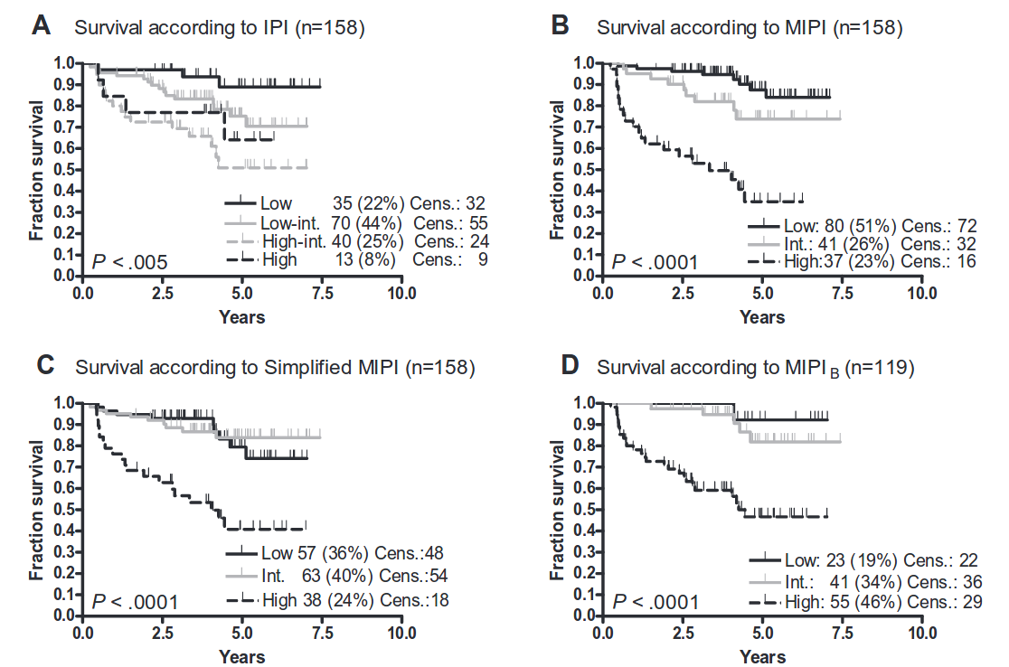

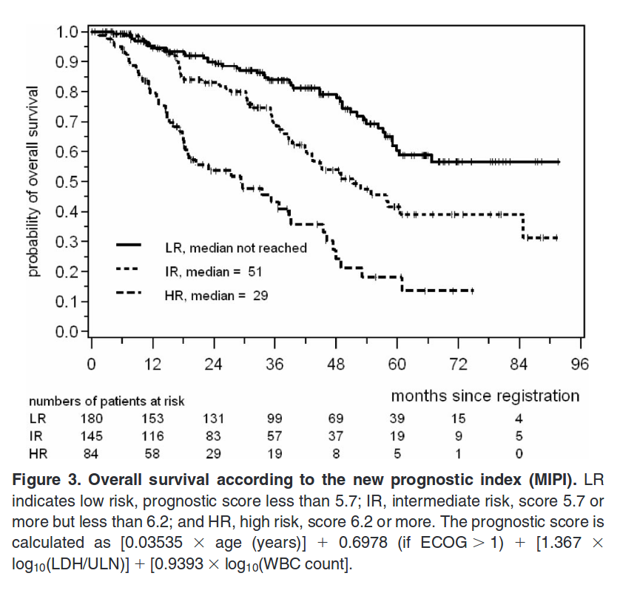Hoster – A new prognostic index (MIPI) for patients with advanced-stage mantle cell

lymphoma

Geen intensieve therapie